**Team Name: Group I**

Members: Isaac Kydd, Theo Truong, Gurkaran Singh Kalra, Kamran Aqeel

**Project sponsor**

Dr. Tim Maciag (ENSE 271 Professor)

**Business need/opportunity**

The Charity Resource Hub will address these challenges by providing a centralized, accessible, and locally relevant online platform that aggregates credible resources, learning materials, and collaboration opportunities. Managed by the South Saskatchewan Community Foundation, this hub will be a trusted source for Saskatchewan charities, giving them the knowledge and tools they need to work efficiently and stay sustainable. This initiative presents an opportunity to:

* Make it easier to find resources, saving time spent searching for information.
* Assist with funding by helping charities find grants and proposal-writing assistance.
* Foster collaboration between nonprofits, strengthening sector-wide impact.

By ensuring that the right resources are easy to find and readily accessible, this project will empower charities to work more efficiently, strengthen their impact, and foster collaboration within the non-profit sector.

**North Star & Carryover Customers**

Our North Star focused on delivering a centralized, user-friendly Charity Resource Hub that empowers Saskatchewan-based non-profits through accessible learning, fundraising, and governance tools. The North Star customers included:

* Small to mid-sized registered charities in Saskatchewan without dedicated HR, strategy, or fundraising teams
* Community-focused organizations relying on networking and shared knowledge

Carryover customers included:

* Organizations already engaged with the South Saskatchewan Community Foundation (SSCF)
* Past workshop and grant participants

**Assumptions and Constraints**

*Assumptions:*

* The website will be built using WordPress for its user-friendliness, scalability, and cost-effectiveness
* Users will find value in features like event tracking, access to recordings, and downloadable notes for post-event use
* Resources will be locally curated to align with Saskatchewan regulations and needs, ensuring credibility and trustworthiness
* Users will feel empowered and confident using the platform if it meets their needs consistently and is updated regularly

*Constraints:*

* Ensuring that event recordings, grant information, and resources remain organized and up-to-date requires a dedicated effort
* Building an effective search and filter system that helps users quickly locate specific information may require technical expertise and testing
* Relying only on external methods like emails or newsletters for communication can make it more challenging, as it limits specific updates and centralized coordination

**Key Findings from Affinity Diagramming and Empathy Mapping**

From our affinity diagram, we discovered a clear demand for categorized resources, grant info, storytelling tools, and support in fundraising and compliance. The empathy map confirmed that:

* Users want **simple navigation**, readable fonts, and accessibility tools
* Information overload is a pain point—users want filtering, categorization, and visual structure
* Resource credibility and Saskatchewan-specific content are key priorities

**USM & MVP Evolution**

Our MVP was defined by these core features:

* Categorized resource access (HR, fundraising, management)
* Grant and fundraising information
* Accessibility features and search functionality

Over time, we evolved this into a full prototype with:

* Translation feature (EN/FR)
* Accordion-style data presentation
* Embedded external resource links

Our solution qualified as an MVP because it addressed our North Star objectives with essential tools while avoiding feature bloat.

**Prototyping and Usability Evaluation Summary**

We began with low-fidelity paper sketches and developed two rounds of high-fidelity prototypes in Figma. Key usability findings:

* Users found **scrolling overwhelming**, especially on mobile
* **Accordion-style content** was seen as a huge improvement
* Design inconsistency and readability issues (fonts, contrast) needed refinement

Based on this, we aligned the final design with:

* **Affordances**: Buttons, icons, and links were visually distinct and interactive
* **Gestalt Principles**: Clear layout using proximity and similarity for groupings
* **Constraints**: Simplified menu options, fewer user decisions to reduce cognitive load

**Reflections on Project Planning, Execution, and Closing**

Our initial project planning didn’t fully align with the customer’s expectations. While our early designs were close to their vision, some proposed features fell outside the intended scope. In particular, we had initially planned to include sections for donors and individuals looking to start funds at SSCF. However, these ideas were later removed, as they didn’t align with the core goal of the website providing a centralized space for charities to access educational resources, organize effectively, and collaborate with one another. We simplified our approach to better reflect the customer's priorities and focus.

**Reflections on Project Results**

We generally feel that we did very well in this project. However, that was not always the case. Towards the beginning, we were unsure of exactly what we needed to do. Our ideas for what the website should be were conflicting, and not accurate to what the customer wanted. We had to go through a very tough refining phase to get our ideas aligned with what was needed to reach the customer’s goals, and it is safe to say that our early designing phases did not go well.

However, once we got our ideas in order, things went much more smoothly. The creation of the website from the high fidelity prototype we had made was challenging, but not undoable. Now that we had a clear picture of what we wanted to make we did quite well. Our wordpress design and implementation went very well, and we are overall very happy with how it turned out in the end.

The people-centered design concepts we learned were crucial in our website turning out the way it did. We tried very hard to keep our design simple, and not to overwhelm the user with a barrage of information and walls of text. We separated concerns in order to increase the useability of the product. Features like translation were added to increase the reach of the site, as well as accessibility gestures like link highlighting, text enlargement, etc, so that our website would be usable by as many people as possible.

In future projects, we would make sure to have a much clearer idea of what the customer wants before we begin creating our prototypes. This would have helped us avoid a lot of the problems and headaches (and inevitable re-designing) that we faced in the early stages, which would have saved us valuable time to be used for improving the final product.

Things that we would likely do the same on future projects are making sure we have a clear understanding of what the custom wants before starting implementation (at the functional level). While our early prototypes were based on incomplete information, our final product was not. Once we had a relatively complete set of data for what we needed to create, we began making the functional wordpress design. It is one thing to remake a low-fidelity or even high-fidelity prototype, but remaking the actual website itself would have been too much. It is critical to be absolutely sure that you understand the customer’s needs before you begin working on implementing your final design.

This project gives us plenty of opportunities for future work. Learning how to make a website is an incredibly useful skill that is valuable not only for employment, but for your own private use (whether commercial or not). It allows you to reach a massive number of people through the internet, which is undoubtedly a more and more useful skill as more of the world becomes connected through the internet.

Overall, this was a very enjoyable project that taught us a lot. From design principles to implementation and everything in between, it was very valuable.

**Screenshots and Final WordPress Solution Summary**

Our final WordPress implementation included:

* Bilingual content switcher (EN/FR)
* Accordion menus for Fundraising, Granting, Storytelling, Resources, and Organizational Management
* Consistent headers and navigation across pages
* Feedback-informed styling improvements: color adjustments, font unification, footer redesign

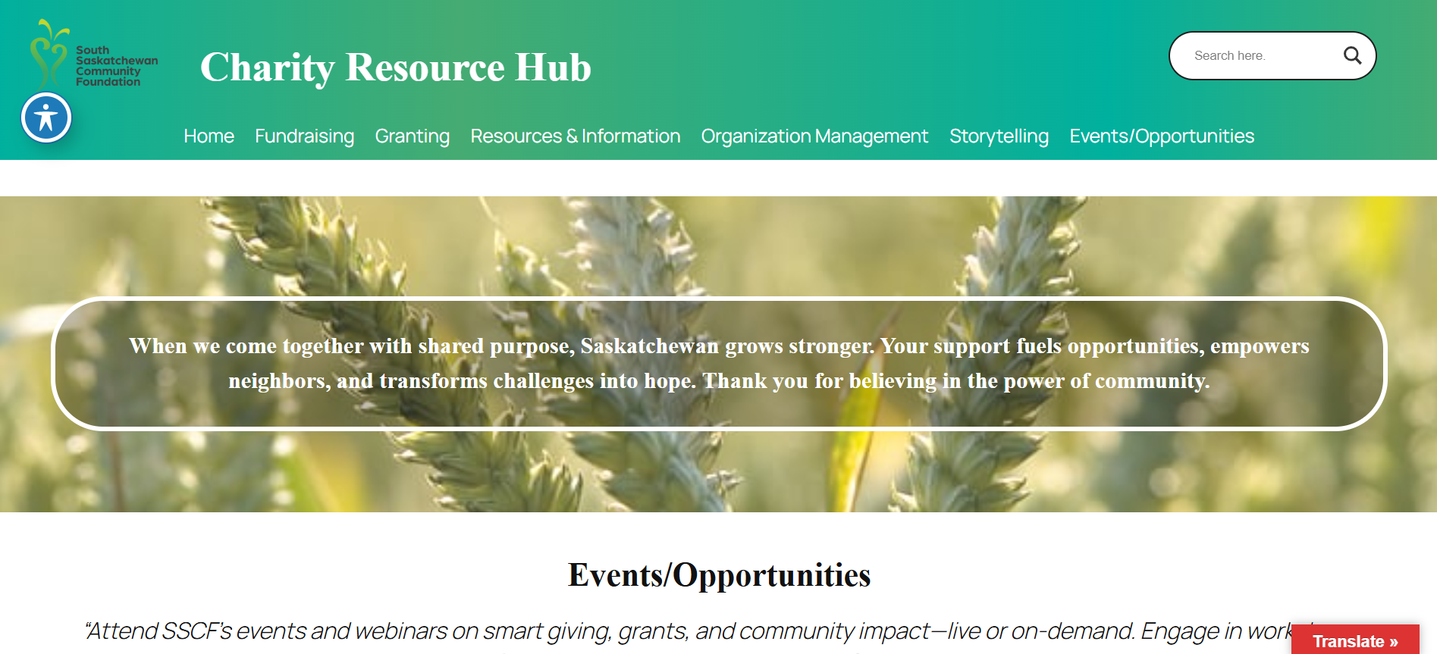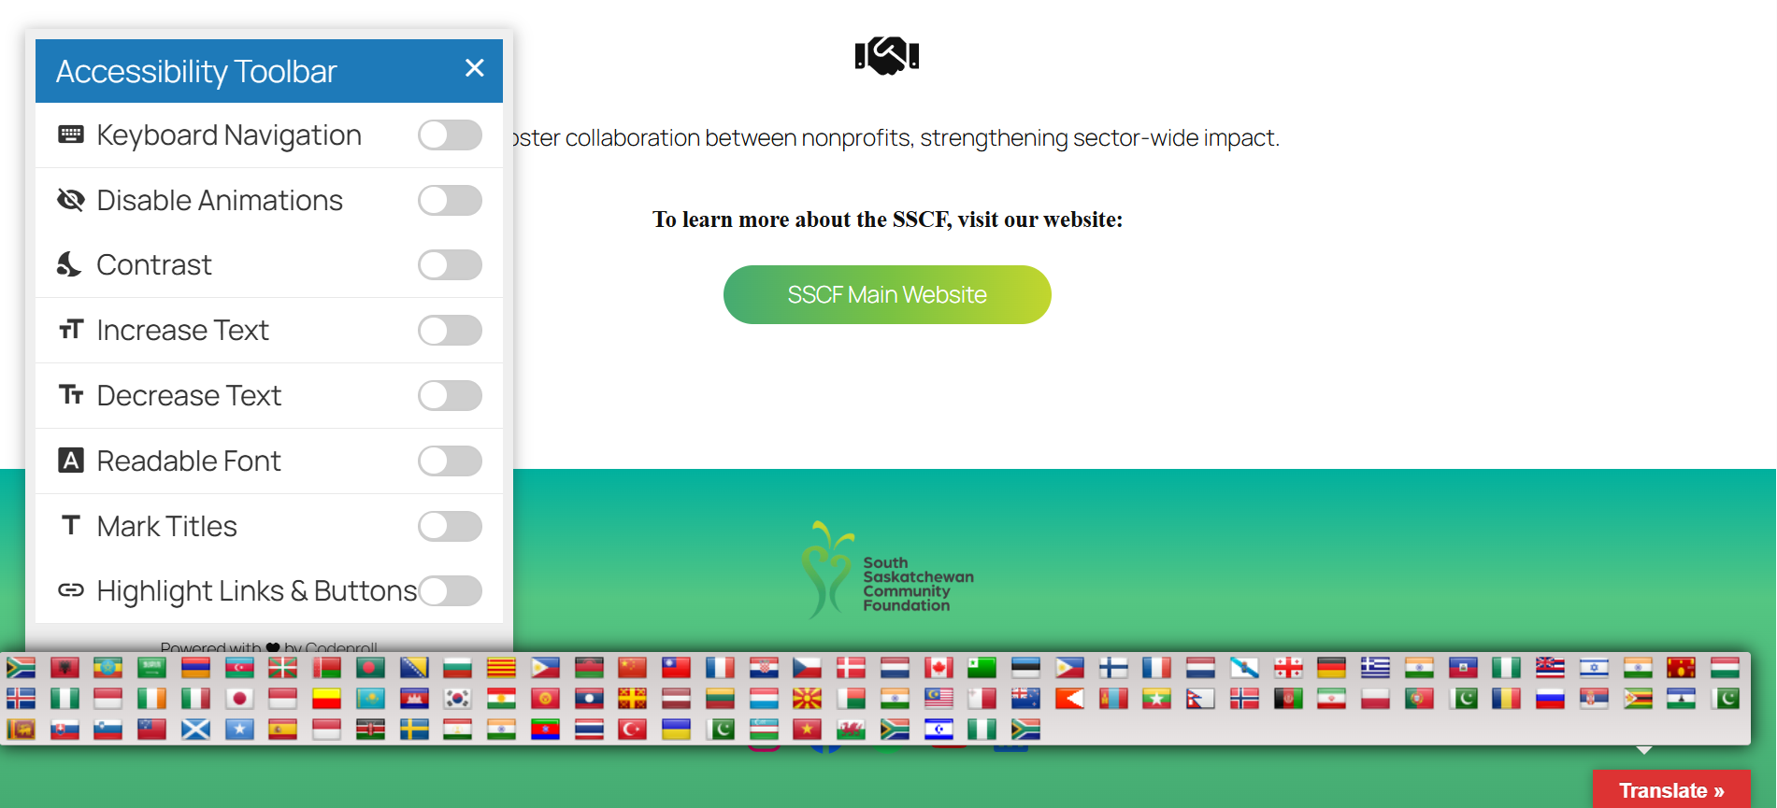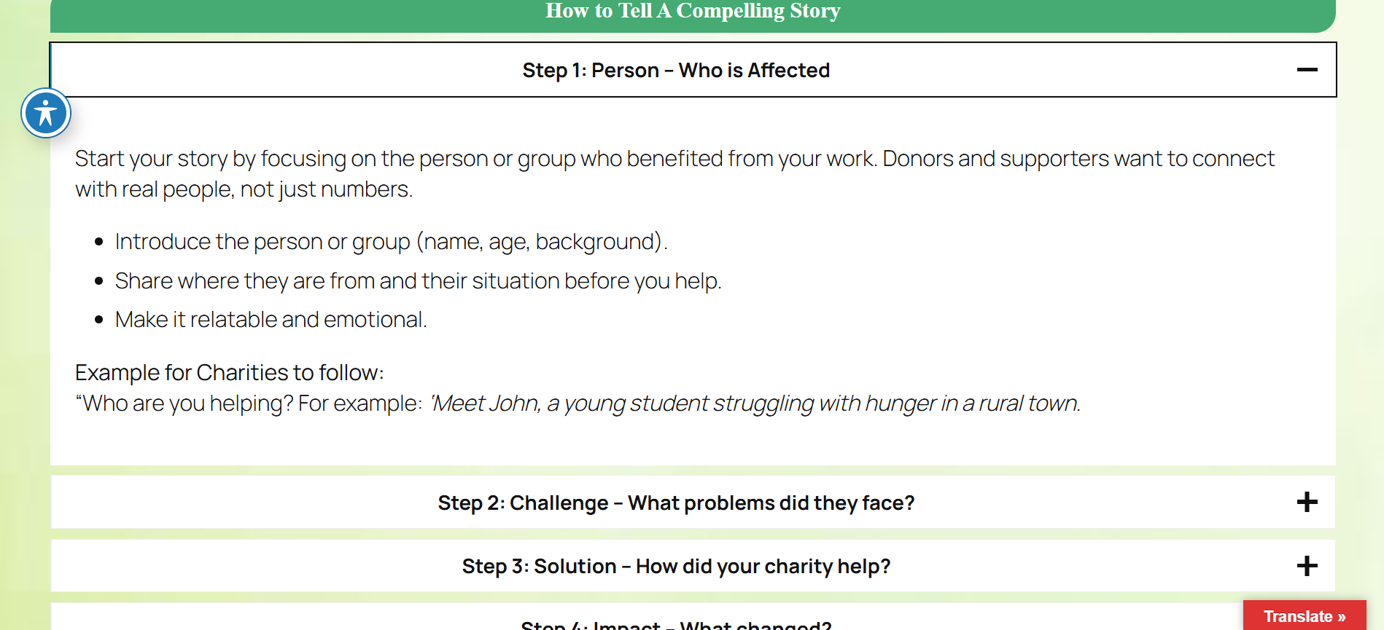

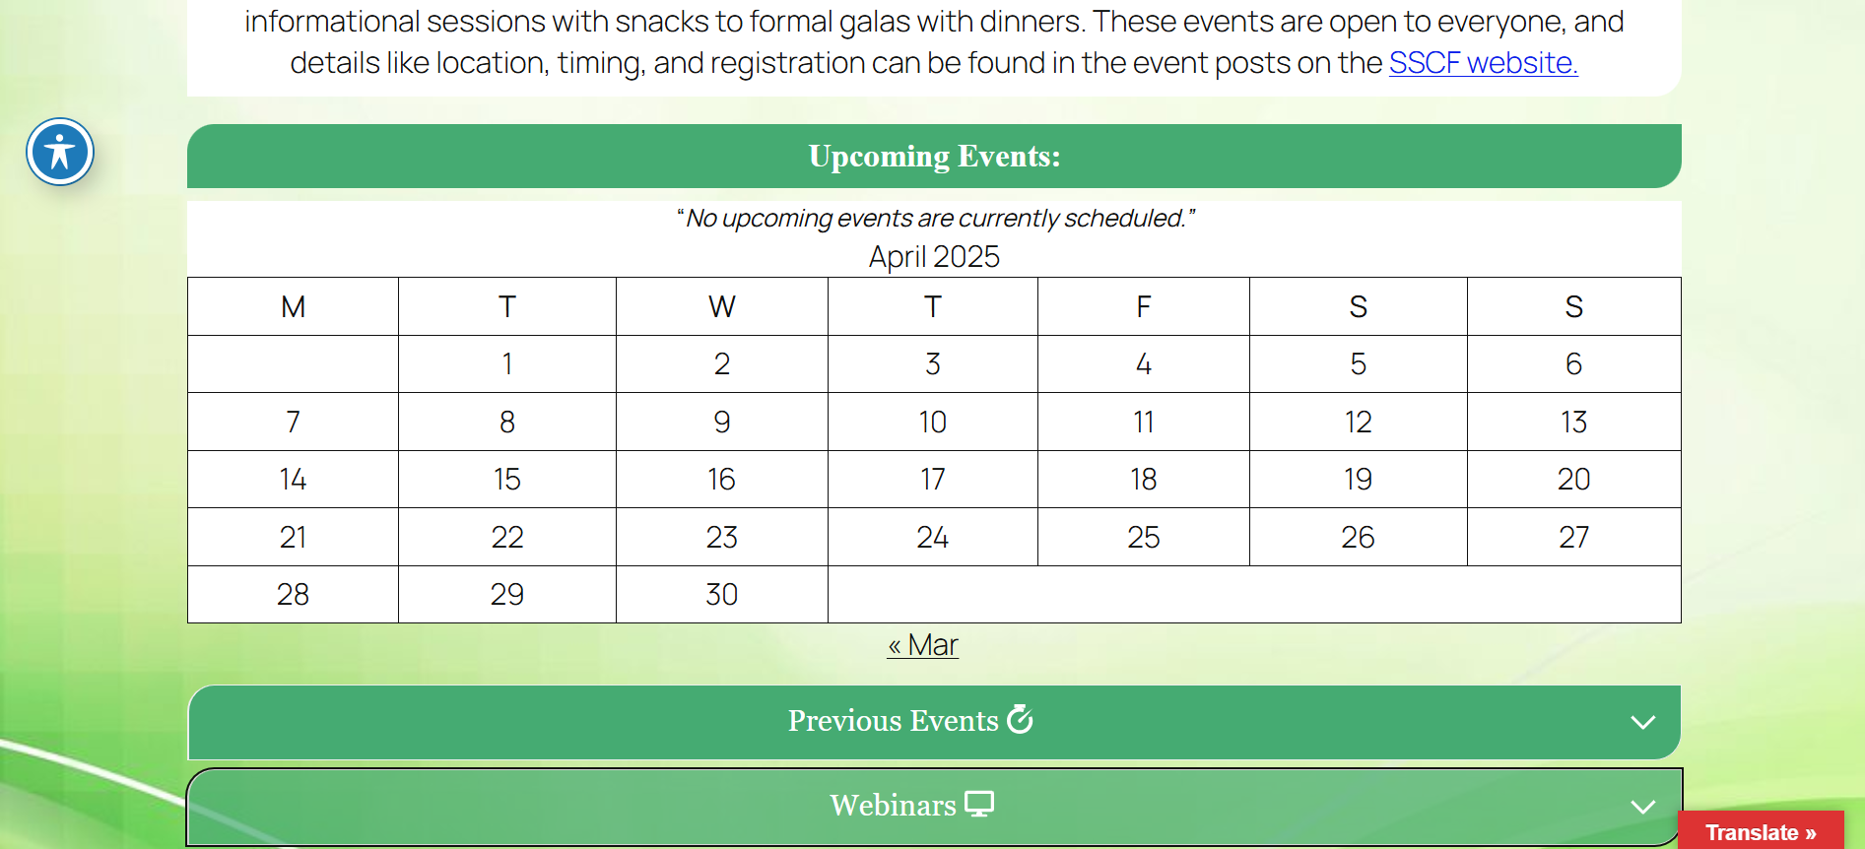

### **Appendix: WordPress themes and plugins**

### 

### 1. Google Language Translator

* Rating: 4.5 out of 5 stars (based on 590 reviews)
* Active Installations: 100,000+
* Last Updated: 5 months ago
* Description: Integrates Google Translate into your WordPress site, allowing visitors to translate content into multiple languages. Offers features like a floating language selector, flag icons, and right-to-left language support.

### 2. AccessibleWP – Accessibility Toolbar

* Rating: 4.5 out of 5 stars (based on 47 ratings)
* Active Installations: 10,000+
* Last Updated: 6 months ago
* Description: Enhances website accessibility by adding a toolbar that provides options such as font size adjustment, contrast changes, and animation toggling to aid users with disabilities.

### 3. Remove Background

* Rating: 1.0 stars out of 5 (based on 1 rating)
* Active Installations: 100+
* Last Updated: 6 months ago
* Description: An AI-powered tool that allows users to remove image backgrounds directly within WordPress, streamlining image editing.

### 4. Spectra

* Rating:4.5 out of 5 starts (based on 1729 reviews)
* Active Installations: 1 million +
* Last Updated: 2 days ago
* Description: Extends the Gutenberg editor with additional blocks and features, enabling more advanced page layouts and designs without coding.

### 5. Kadence Blocks – Gutenberg Blocks for Page Builder Features

* Rating: 5.0 out of 5 stars (279 reviews)
* Active Installations: 500,000+
* Last Updated: 1 week ago
* Description: Provides advanced blocks for the Gutenberg editor, including customizable rows, columns, and content elements, facilitating complex layouts.

### 6. Depicter

* Rating: 4.5 out of 5 stars (based on 201 reviews)
* Active Installations: 100,000+
* Last Updated:4 months ago
* Description: A versatile plugin for creating sliders, carousels, and popups with a user-friendly interface, supporting various content types including WooCommerce products.

### 7. Content Slider Block

* Rating: 3.0 out of 5 stars (from 5 ratings)
* Active Installations: 4,000+
* Last Updated: 2 months ago
* Description: Adds a content slider block to the Gutenberg editor, allowing for the creation of engaging, sliding content sections within posts and pages.

### 8. Ajax Search Lite

* Rating: 4.5 out of 5 stars (from 245 ratings)
* Active Installations: 80,000+
* Last Updated: 2 months ago
* Description: Enhances the default WordPress search with a live AJAX search bar, providing real-time search results with a responsive design.